 | E-BOOK SHOPPING  Technical Design Document  1.0
 | Prepared By / Last Updated By | Reviewed By | Approved By
Name | Amitoj Wadhera, Nimit Gupta, Mohit Arora, Monika Choudhary | Mr. Abhinandan | Mrs. Shilpa Mahajan
Role | Team Members | Mentor | Academy Head
Signature
Date

Table of Contents

1.0 Introduction 3
1.1 Purpose of this document 3
1.2 Scope 3
1.3 Intended Audience 3
1.4 Definition & Acronyms 3
2.0 Conventions and Standards Followed 4
3.0 Assumptions, Dependencies and Risks 4
3.1 Assumptions: 4
3.2 Dependencies: 4
4.0 Schematic Diagram 4
5.0 Use Case Realization 5
5.1.1 User Registration 5
a. Functional Requirement 6
b. UI Validations 6
c. UI Controls 7
d. UI Methods Definition 8
e. UI Design 9
6.0 Database Design 10
6.1 Data Model 10
6.2 Tables Structure 10
7.0 Change Log 13

Introduction

Purpose of this document
The purpose of the detail design document is to define the detailed design for all the components of E-Book Shopping that are specified in the Business Requirement/Use case document. All the low level components, interfaces and integrations are detailed out in this document.

Scope
This sub-section shall state the scope of this detailed design document
• Create and maintain user information.
• Create and maintain admin information.
• Create and maintain order and payment information.

Intended Audience
The intended audience for this document are
- Developers, testers, other associates in the project
- Technical lead, Scrum Master
- Product Owner

Assumptions, Dependencies and Risks

Assumptions:
- Once the application is built, the E-Book Shopping will manually load the book list into the system.
- There will be no concurrent users for the application. The User and Admin will maintain the User and Admin profile respectively.
- Any changes to the design mentioned in the BRD would be taken as a Change Request.

Dependencies:
- Availability of database design characteristics & access shall be defined.
- Resource availability throughout each of the sprint

Schematic Diagram
A schematic, or schematic diagram, is a representation of the elements of a system using abstract, graphic symbols rather than realistic pictures. It gives an overview of overall system

Data Flow Diagram for E-Book Shopping

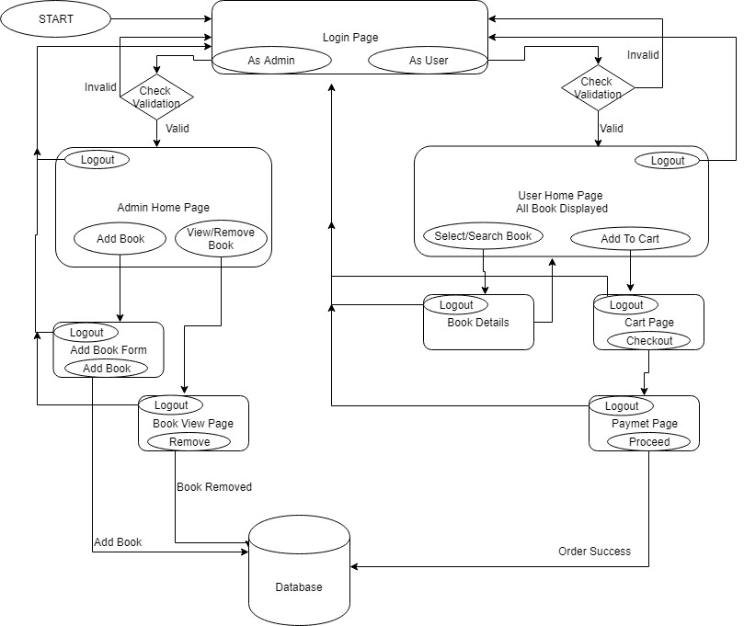

Use Case Realization

User/Admin Registration

Functional Requirement
Login Page checks the authentication of the user/admin and based on his role, directs the user to the respective page. Admin will be provided with links to add new books and edit available books. User will be provided with links to select the respective books and pay for it and will be allowed to see the receipt and the status of payment.

UI Validations
- User Id and Password fields are mandatory.
- Invalid User Id and / or password should not allow the user to get into the system

UI Controls
# | UI Component | Type | Name | Details
1 | Username | Text Field | userId | To enter username
2 | Password | Password | password | To enter password

UI Methods Definition
Method Name | Parameter | Details
LoginButton_Click | object sender, EventArgs e | Allows the user/admin to login into the portal.
CreateAccountButton_Click | object sender, EventArgs e | Allows user to register into the system.
HomeButton_Click | object sender, EventArgs e | Loads the Homepage whenever clicked.
AddBookHereButton_Click | object sender, EventArgs e | Allows the admin to add a new book by entering all the details of the book.
View/RemoveButton_Click | object sender, EventArgs e | Allows one to view the content of the selected book or remove from database.
SearchButton_Click | object sender, EventArgs e | Allows one to search the policy.
AddToCartButton_Click | object sender, EventArgs e | Allows the user to view all the purchased Books.
Checkout_Click | object sender, EventArgs e | Allows user to buy the book.

UI Design
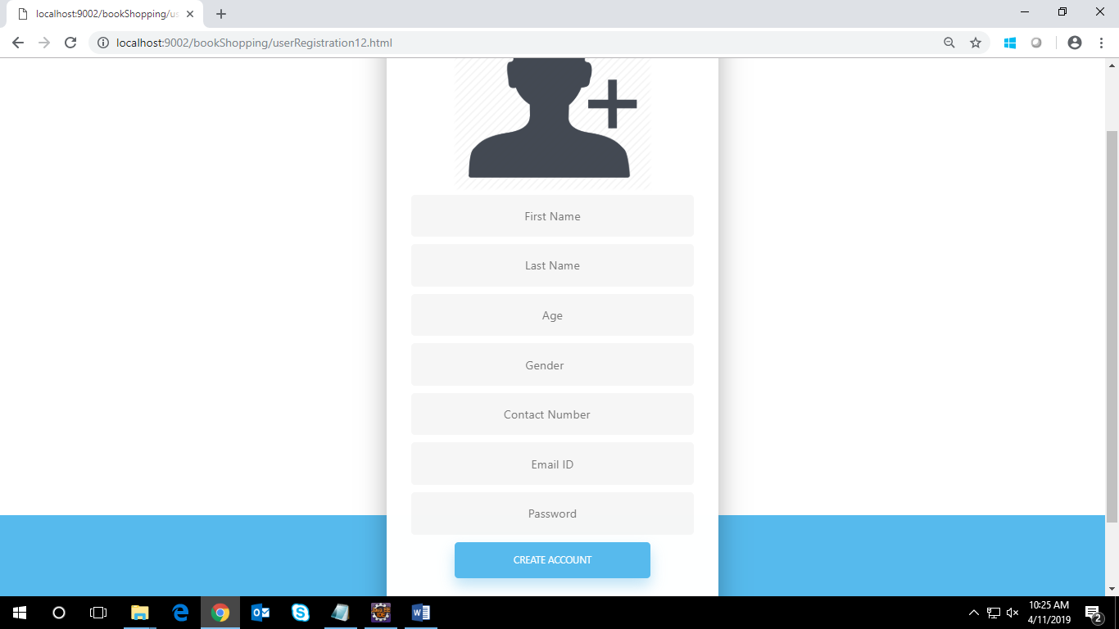

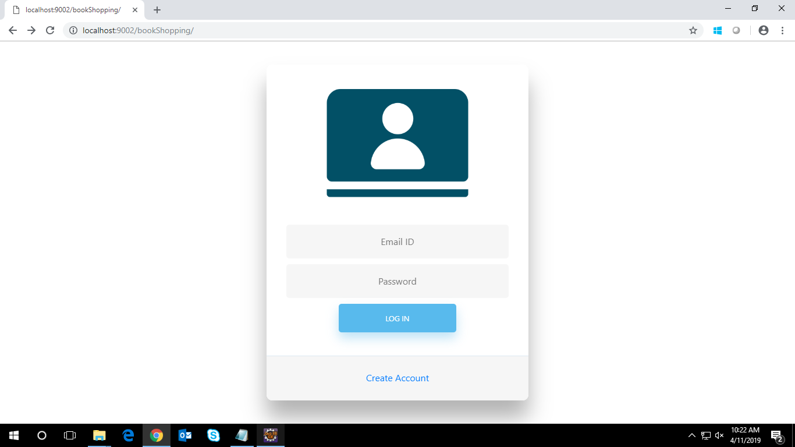

Database Design

Data Model

The following is a schematic view of the database design
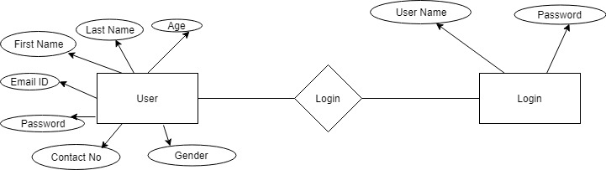

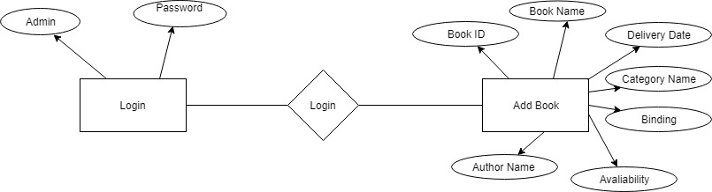

Tables Structure
User Registration Details:
Column Name | Data Type | Length | Nulls
firstName | varchar | 255 | N
lastName | varchar | 255 | N
age | varchar | 255 | N
gender | varchar | 255 | N
conatctNumber | varchar | 255 | N
emailId | varchar | 255 | N
password | varchar | 255 | N

Book Details:
Column Name | Data Type | Length | Nulls
bookId | varchar | 255 | N
bookName | varchar | 255 | N
authorName | varchar | 255 | N
availability | varchar | 255 | N
binding | varchar | 255 | N
catName | varchar | 255 | N
DeliveryDate | datetime |  | N

Change Log
Please note that this table needs to be maintained even if a Configuration Management tool is used.
Version Number | Changes made
V1.0 | <First version>
V1.1 | <If the change details are not explicitly documented in the table below, reference should be provided here>
V1.1 | Page no | Changed by | Effective date | Changes effected
V1.2 | <If the change details are not explicitly documented in the table below, reference should be provided here>
V1.2 | Page no | Changed by | Effective date | Changes effected

